**“Tasty” Application**

1. **Introduction**

Idea is to develop a simple mobile application that compares user ratings for dishes in the restaurants within the vicinity of the mobile user. Users can use this information to order dishes online through partner applications (e.g. Swiggy)

1. **List of Features:**
   1. User Registration
   2. Personalization - User preferences – dishes, hotel stars, veg/non-veg. ambience, quality
   3. Simple survey questions to capture ratings and text feedback
   4. Provide ongoing recommendations
   5. Share foodie events happening in your city
   6. Casually share trending news from entertainment and sports
2. **Market Survey:**

I do not see applications comparing use ratings for specific dishes by restaurants. Typically the comparisons are by restaurants based on their cost, quality, ambience etc.,

1. **References:**

Various product websites that compares products by features and customer feedback

1. **User Interface Design and Prototype:**

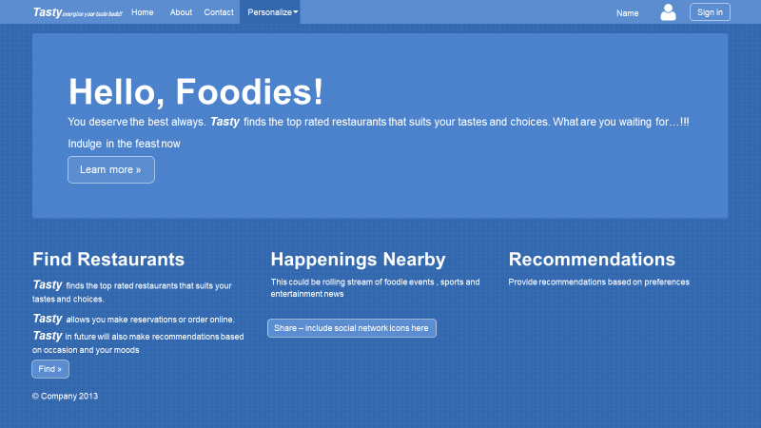

1. **Navigation Structure:**

**Navigation Bar:** Top navigation bar allows to navigate to any of the top level pages of the website as well as login to the site



**About:** Clicking on “About” from Navigation bar and “Learn more” in the main page will take you to the About page

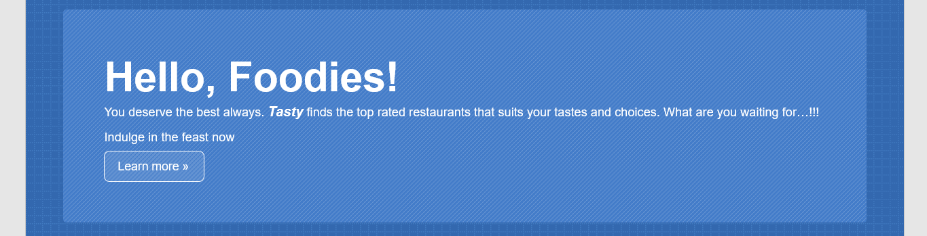

**Find restaurants** Allows you to search restaurants based on various criteria

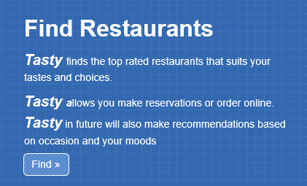

**Happenings Nearby:** streaming of foodie events , Trending of events – sports and entertainment

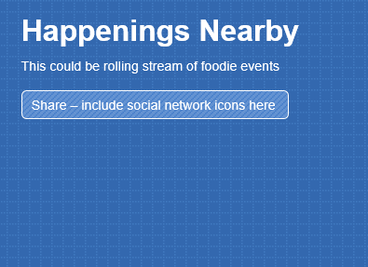

**Recommendations:** recommendations based on preferences

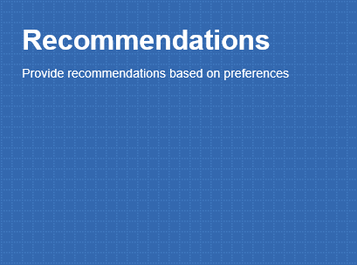

**About:** Describe the site, founders and features



**Contact:** Describe contact us site



**Preferences:** Save your preferences

